BMW GLOBAL SALES DATA ANALYSIS AND DASHBOARD

1. Introduction
This project focuses on analyzing the BMW Global Sales dataset (2018–2025) using Microsoft Excel and Power Query.
The objective is to identify trends, patterns, and key business insights across regions and vehicle models.
The dataset includes important metrics such as revenue, units sold, average price, GDP growth, and premium share.
Excel tools such as IF, IFS, AND, OR, NOT, Pivot Tables, and dashboards were used to perform the analysis.

2. Objectives
- To analyze revenue trends across different years
- To compare sales performance across regions
- To evaluate model-wise pricing and sales
- To understand the impact of premium share on revenue
- To clean and preprocess the dataset for accurate analysis
- To create calculated columns using logical functions
- To build an interactive dashboard for visualization
- To derive meaningful insights for business decision-making

3. Data Source
- Dataset Name: BMW Global Sales Dataset
- Time Period: 2018–2025
- Tools Used: Microsoft Excel, Power Query
- Key Columns: Revenue, Units Sold, Average Price, GDP Growth, Premium Share, Region, Model, Year

4. Data Cleaning (Preprocessing)
The dataset was cleaned to ensure consistency and accuracy. The following steps were performed:
- Verified dataset (no null values present)
- Removed duplicate records
- Corrected data types using Power Query
- Renamed columns for better readability
- Ensured data consistency

5. Data Transformation
The dataset was transformed using the following techniques:
- Data cleaning and shaping using Power Query
- Created new columns using:
  - IF / IFS
  - AND / OR / NOT
- Converted revenue into Million (M EUR) format
- Created Pivot Tables for aggregation and analysis

6. Dashboard Creation
An interactive dashboard was created using Pivot Charts and slicers.
Features:
- Revenue trend over years
- Region-wise revenue distribution
- Model-wise performance analysis
- Average price comparison
- Premium share analysis
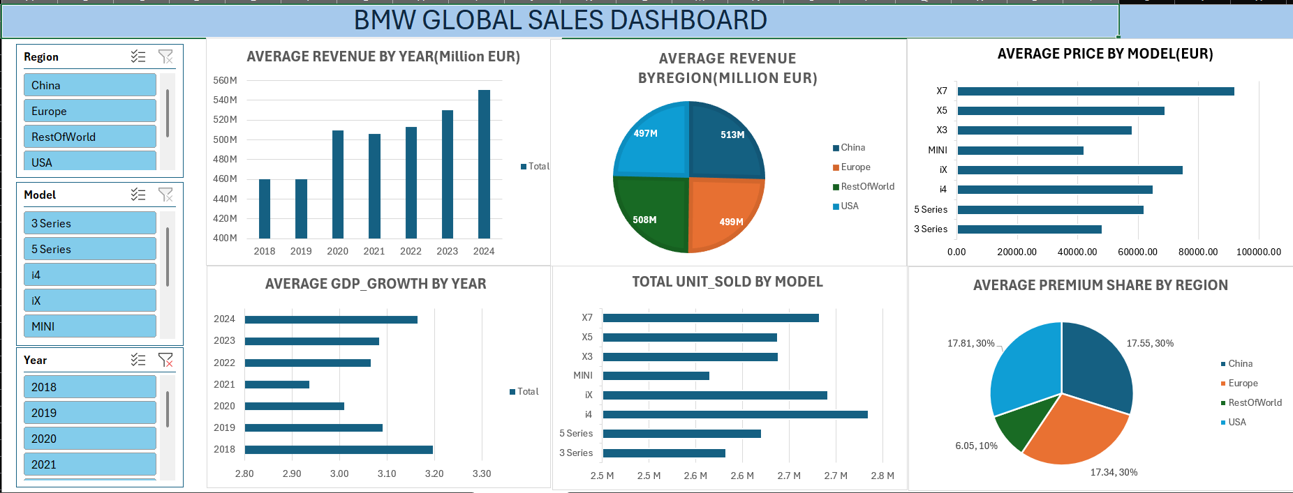
Interactive Elements:
- Slicers:
  - Year
  - Region
  - Model
The dashboard provides a clear and visual representation of sales performance.

7. Key Insights
Descriptive Analysis (What happened?)
- Revenue increased from 460M EUR (2018) to 561M EUR (2025), showing consistent growth.
- China has the highest average revenue (~523M EUR), while Europe and USA are around ~506M EUR, indicating balanced regional performance.
Diagnostic Analysis (Why it happened?)
- Revenue growth is driven by higher average prices, with premium models like X7 (~92K EUR) and iX (~75K EUR) contributing significantly.
- Regions with higher premium share such as USA (17.76%), China (17.57%), and Europe (17.33%) generate more revenue, while Rest of World (5.99%) contributes less.
Predictive Analysis (What will happen?)
- Based on current trends, revenue is expected to continue growing beyond 561M EUR in future years.
- Demand for premium models like X7 and iX is likely to increase as their current sales are already strong (~3.1M units each).
Prescriptive Analysis (What should be done?)
- Focus on expanding premium models such as X7 and iX, which have both high price (~92K EUR) and high sales (~3.1M units).
- Improve premium share in Rest of World (currently ~6%) to increase overall revenue.
- Optimize pricing strategies to maintain average revenue around 511M EUR+ and drive further growth.

8. Conclusion
The analysis highlights steady revenue growth and consistent performance across regions. Premium models play a significant role in driving revenue.
Using Excel and Power Query, meaningful insights were generated effectively. This project demonstrates the importance of data-driven decision-making in business analysis.

